Publishing to BMA

Server: BackendFunctions

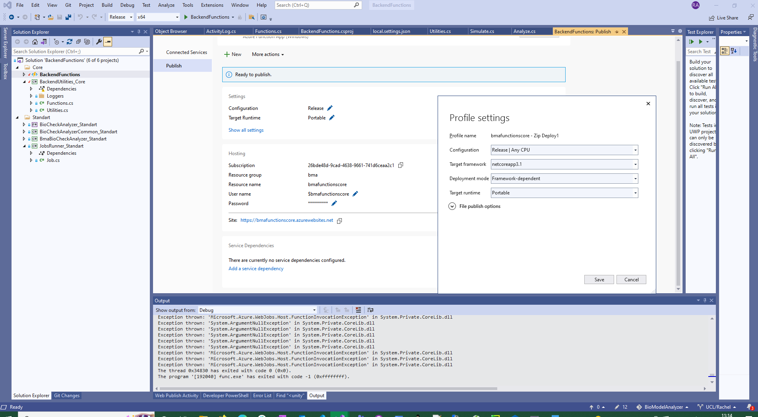

If in doubt the existing application should be retrievable

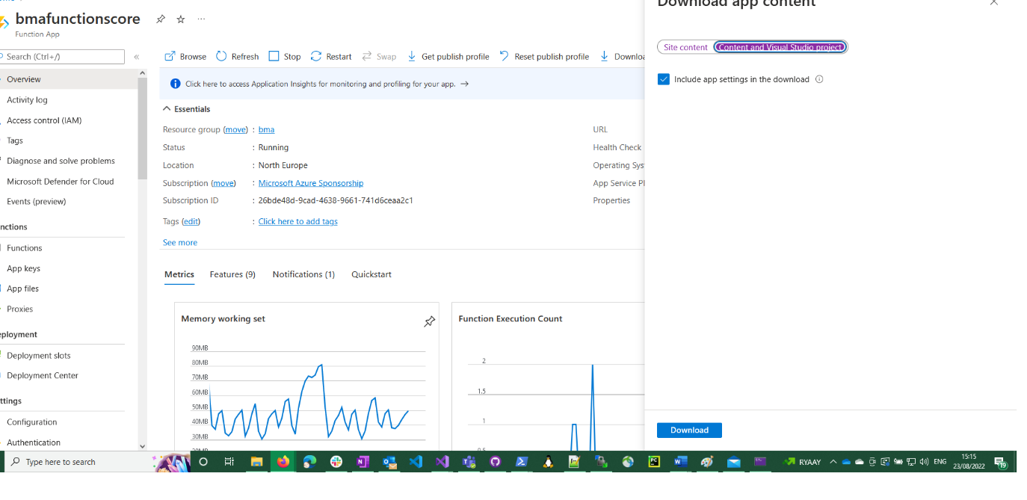

Functions can be tested directly in Azure:

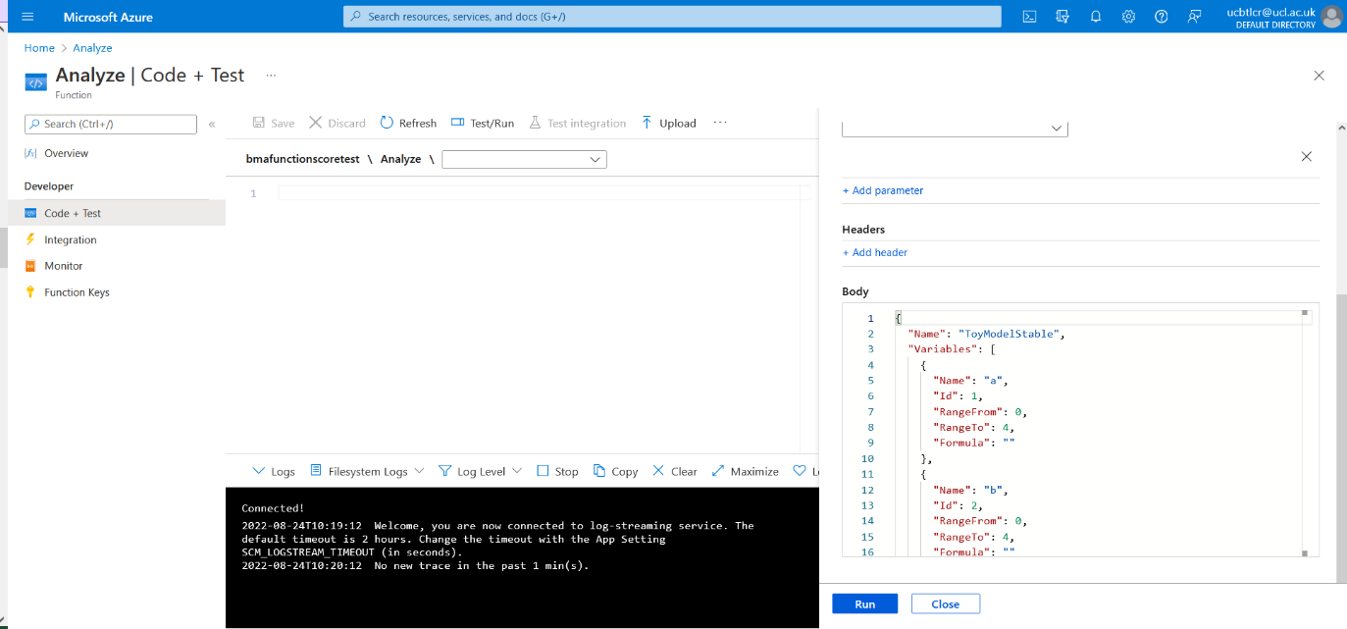

It needs CORS for java script to work:

